1. **Reactjs-HOL**

**Step 1.** If youdon’thave node and npm installed install them through this link

<https://nodejs.org/en/download/>

**Step 2.** Run the following command in your folder’s terminal

**“npx create-react-app myfirstreact”,** this will create a new react app for you

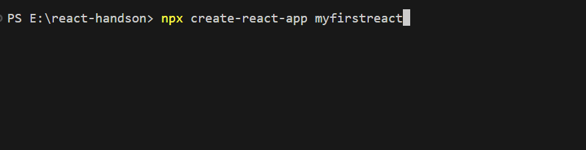

**Step 3.** Change the folder via “**cd myfirstreact”** command

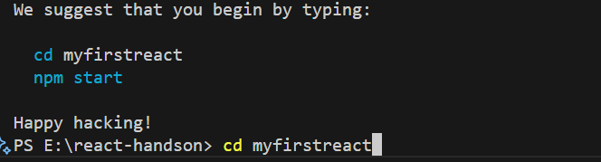

**Step 4.** In the app.js file, which should be present automatically in your src folder, type the following given code.

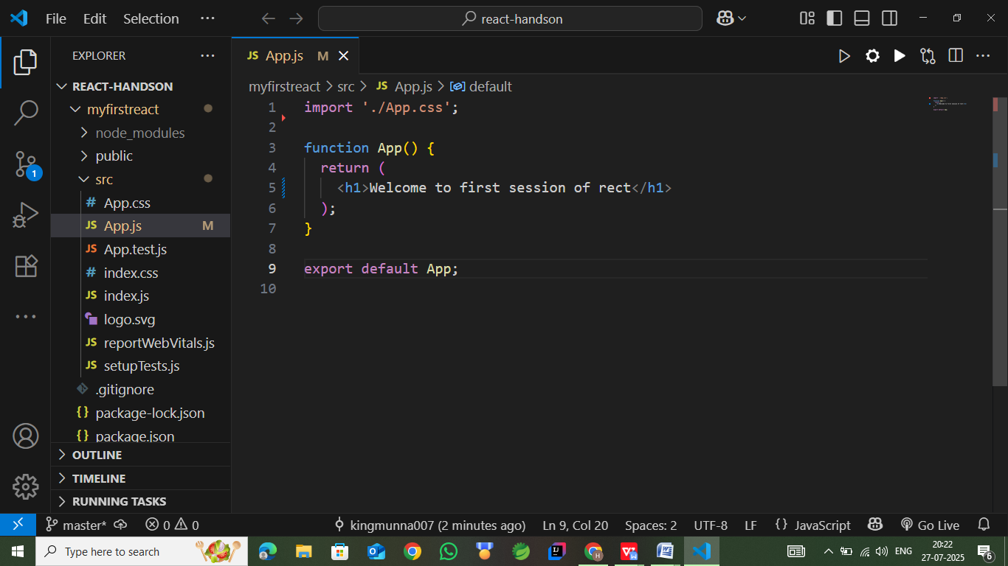

**Step 5.** To start the react app, you should use the following command

**“npm start”**

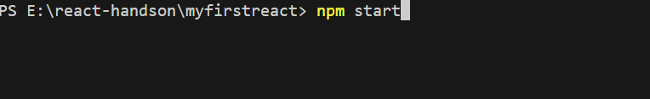

**Output:**

After a few moments the output should be visible on your browser at port 3000.

